# Tutorial 02 – Variables

This tutorial is aimed at giving you some familiarity with variables.

Do not worry if you can’t do all the exercises, especially the difficult ones. Give them a try and if you are stuck, ask your tutor.

You should make a record all of your work in your COMP1753 logbook. This should be a Word document or similar that you update each week. Paste in screenshots of the output and make notes of what changes you had to do to the code.

1. Download and check through “L01 Introduction solutions.zip” – the solutions to last week’s tutorial exercises. You should do this every week from now on.
2. Download “L02 Variables.zip” and unzip it. **Note: you must unzip it – you will not be able to edit the examples if you don’t.**
3. Make a copy of 09Addition and save it to 03Multiplication. Now modify it to do multiplication.

number1_str = input(" First number: ")

number2_str = input("Second number: ")

number1 = int(number1_str)

number2 = int(number2_str)

combination = number1 * number2

combination_str = str(combination)

print("Answer: " + combination_str)

print()

input("Press return to continue ...") 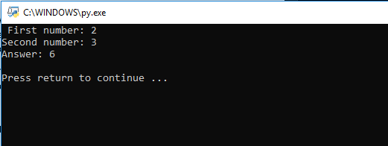

1. Make a copy of 10Subtraction and save it to 04Division, then modify it to do division. Currently it has 6 variables; without looking at the lecture notes:

number1_str = input(" First number: ")

number2_str = input("Second number: ")

number1 = int(number1_str)

number2 = int(number2_str)

combination = number1 / number2

combination_str = str(combination)

print("Answer: " + combination_str)

print()

input("Press return to continue ...")

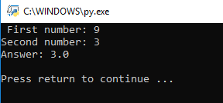

* 1. Can you modify it to eliminate some of them?
  2. [Harder] Can you modify it to eliminate all of them?

(please give a look at the calcul file )

1. Modify 14RandomValues so that it produces 5 random numbers, rather than 4. Save it to 05RandomValues.

from random import randint

min_str = input("Min: ")

max_str = input("Max: ")

minimum = int(min_str)

maximum = int(max_str)

random1 = randint(minimum, maximum)

random2 = randint(minimum, maximum)

random3 = randint(minimum, maximum)

random4 = randint(minimum, maximum)

random5 = randint(minimum, maximum)

print(str(random1) + " " + str(random2) + " " + str(random3) + " " + str(random4)+ " " + str(random5))

print()

input("Press return to continue ...")

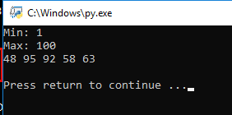

1. Write a program called 06HelloLucky which asks the user for their name and generates a random ‘lucky’ number for them. The output should say “Hello [name], your lucky number is [number]” where [name] is the name input by the user and [number] is the randomly generated number. The lucky number should be between 1 and 100.

from random import randint

name = input("what is your name ?: ")

minimum = 1

maximum = 100

lucky = randint(minimum, maximum)

lucky = str(lucky)

print()

print("hello " + name + " your lucky number is " + lucky)

input("press enter to end")

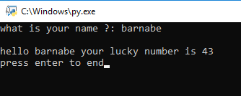

1. Write a program called 07HelloLuckyYear which asks the user for their name and year of birth and then “guesses” a random year which will be lucky for them. The output should say “Hello [name], your lucky year is [year]” where [name] is the name input by the user and [year] is the randomly generated lucky year. The lucky year should be between 0 and 70 years after their year of birth.

from random import randint

name = input("what is your name ?: ")

year = input("what is your year of birth?: ")

minimum = int(year)

maximum = int(year)+70

lucky = randint(minimum, maximum)

lucky = str(lucky)

print()

print("hello " + name + " your lucky number is " + lucky)

input("press enter to end")

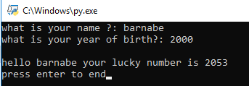

1. Read the w3schools pages mentioned in the lecture. We have not covered everything there but this will give you more insight into how variables and data types work:
   1. <https://www.w3schools.com/python/python_variables.asp>
   2. <https://www.w3schools.com/python/python_casting.asp>
   3. <https://www.w3schools.com/python/python_numbers.asp>